Healthcare Patient Deterioration Analytics using Azure Medallion Architecture

Project Overview
This project presents an end-to-end Healthcare Patient Deterioration Analytics platform built using the Azure ecosystem. The solution implements the Medallion Architecture (Bronze, Silver, Gold) to create a scalable and reliable data pipeline. Raw patient vital data is ingested through Azure Data Factory, stored in Azure Data Lake Storage Gen2, transformed using PySpark in Azure Databricks, and finally visualized through interactive Power BI dashboards.

The project also integrates a Machine Learning pipeline using Spark MLlib to predict patient deterioration within the next 12 hours based on patient vitals, laboratory measurements, demographic information, and engineered clinical features.

Problem Statement
The problem statement is to design a scalable healthcare analytics platform capable of transforming raw patient monitoring data into trusted analytical datasets while enabling machine learning–based prediction of patient deterioration.

Project Objective
- Design a cloud-based healthcare analytics pipeline using Microsoft Azure.
- Implement the Medallion Architecture (Bronze, Silver, Gold).
- Perform automated data ingestion using Azure Data Factory.
- Apply data validation and feature engineering using PySpark.
- Build business-ready Gold layer tables for analytics.
- Train a Random Forest classifier to predict patient deterioration.
- Develop interactive Power BI dashboards for healthcare analytics.
- Demonstrate an end-to-end modern Data Engineering workflow.

Architecture Diagrams

- Solution Architecture

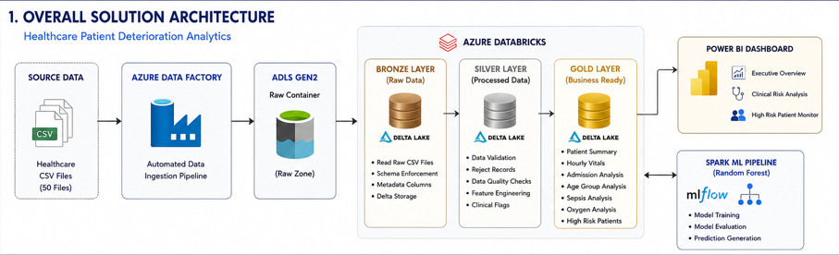

- Medallion Architecture

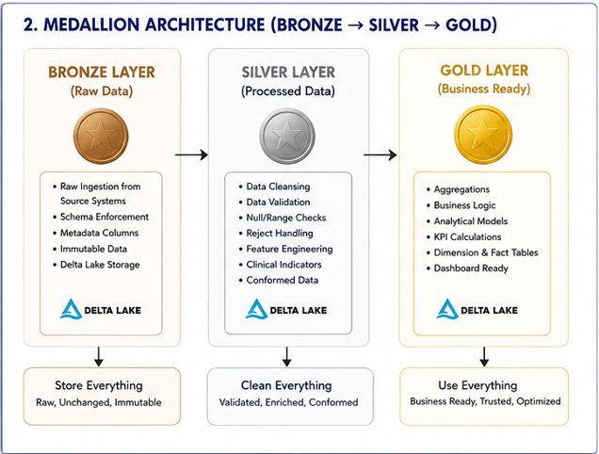

- Data Flow Architecture
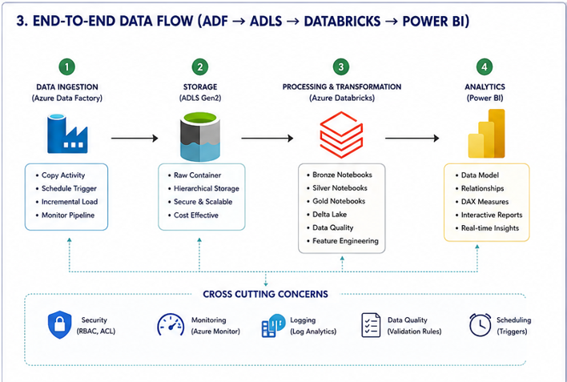

Solution Architecture
The architecture follows the Medallion Architecture pattern to progressively improve data quality and transform raw healthcare records into business-ready analytical datasets.

The solution begins with structured healthcare CSV files containing patient vital signs, laboratory measurements, demographic information, and clinical observations. Azure Data Factory automates the ingestion of these files into Azure Data Lake Storage Gen2, where the raw data is preserved without modification.

Azure Databricks processes the data through three logical layers—Bronze, Silver, and Gold. Each layer has a clearly defined responsibility. The Gold layer serves as the source for interactive Power BI dashboards, while the Silver layer provides clean feature-rich data for the machine learning pipeline.

The architecture separates ingestion, transformation, analytics, and machine learning into independent components, making the solution modular and easy to maintain.

Technology Stack
Category | Technology
Cloud Platform | Microsoft Azure
Data Ingestion | Azure Data Factory
Data Lake | Azure Data Lake Storage Gen2
Processing Engine | Azure Databricks
Language | Python
Distributed Processing | Apache Spark (PySpark)
Storage Format | Delta Lake
Machine Learning | Spark MLlib
ML Algorithm | Random Forest Classifier
Reporting | Microsoft Power BI
Version Control | Git & GitHub

Dataset Description
The project uses healthcare monitoring dataset consisting of 50 CSV files, each containing patient observations collected at regular monitoring intervals.
Each file follows an identical schema and contains patient demographics, physiological measurements, laboratory test results, oxygen therapy information, and the target variable indicating whether the patient deteriorated within the next twelve hours.

Attribute | Value
Dataset Type | Structured CSV
Number of Files | 50
Total Records | ~417,866
File Format | CSV
Processing Framework | Apache Spark
Storage | Azure Data Lake Storage Gen2

Data Pipeline
The data pipeline automates the ingestion and transformation of healthcare records using Azure Data Factory and Azure Databricks.
The pipeline consists of the following stages:
Step 1 – Data Ingestion
Healthcare CSV files are stored in the source container.
Azure Data Factory copies all files into the Raw container within Azure Data Lake Storage Gen2.
Step 2 – Bronze Layer
The Bronze notebook performs:
- Manual schema definition
- Raw data ingestion
- Metadata addition
- Delta Lake storage
Step 3 – Silver Layer
The Silver notebook performs:
- Data validation
- Reject record handling
- Null validation
- Feature engineering
- Clinical indicator generation
A separate reject table captures invalid records along with rejection reasons.
Step 4 – Gold Layer
Business-ready analytical datasets are generated, including:
- Patient Summary
- Hourly Vitals
- Admission Analysis
- Age Group Analysis
- Sepsis Analysis
- Oxygen Analysis
- High Risk Patients
These datasets are optimized for reporting and dashboard creation.
Step 5 – Analytics
Power BI connects to exported Gold-layer datasets to create interactive dashboards for healthcare analytics.

Medallion Architecture
Bronze Layer
The Bronze layer stores raw healthcare data exactly as it is received from the source system.
Responsibilities include:
- Schema enforcement
- Metadata enrichment
- Delta Lake storage
- Historical preservation
No data cleansing or transformation is performed at this stage.

Silver Layer
The Silver layer transforms raw healthcare data into trusted analytical datasets.
Key operations include:
- Null validation
- Reject record separation
- Data quality validation
- Feature engineering
- Clinical indicator creation
Engineered Features:
- is_fever
- is_tachycardia
- is_hypoxic
- high_sepsis_risk
- pulse_pressure

Gold Layer
The Gold layer contains business-ready aggregated datasets.
Generated tables include:
- Gold Patient Summary
- Gold Hourly Vitals
- Gold Admission Analysis
- Gold Age Group Analysis
- Gold Sepsis Analysis
- Gold Oxygen Analysis
- Gold High Risk Patients
These tables are optimized for reporting and visualization.

Machine Learning Pipeline
A machine learning pipeline is developed using Apache Spark MLlib. The objective of the model is to predict whether a patient is likely to deteriorate within the next 12 hours based on current clinical observations.
Workflow
The machine learning pipeline follows the standard Spark ML workflow:
- Feature Selection
- Train-Test Split (80:20)
- Categorical Feature Encoding
- Feature Vector Assembly
- Random Forest Model Training
- Prediction Generation
- Model Evaluation
Feature Engineering
- Pulse Pressure
- Is Fever
- Is Tachycardia
- Is Hypoxic
- High Sepsis Risk
These features were combined with the original physiological measurements, laboratory results, demographic information, and admission details.
Model Evaluation
The model was evaluated using:
- Accuracy
- Precision
- Recall
- F1 Score
- ROC-AUC

PowerBI Dashboard
An interactive Power BI dashboard is developed using Gold layer datasets. The dashboard enables users to monitor patient health, analyze clinical risk factors, and identify high-risk patients.
The dashboard is organized into three analytical pages.
Page 1 – Executive Overview
Provide hospital management with a high-level summary of patient health.
Key Components
- Total Patient Observations
- Average Heart Rate
- Average SpO₂
- Average Temperature
- Average Sepsis Risk
- Deterioration Rate
- Hourly Vital Trends
- Patient Distribution by Age Group
- Patient Distribution by Admission Type
Page 2 – Clinical Risk Analysis
Support clinical decision-making by highlighting patient risk patterns.
Key Components
- Sepsis Risk Comparison
- Oxygen Device Analysis
- Deterioration Rate by Age Group
- Average Sepsis Risk by Admission Type
Page 3 – High Risk Patient Monitor
Provide an operational view of patients classified as high risk.
Key Components
- High Risk Patient Table
- Admission Type Filter
- Gender Filter
- Oxygen Device Filter
- Age Filter
- Clinical KPI Summary
- Conditional Formatting for Critical Measurements

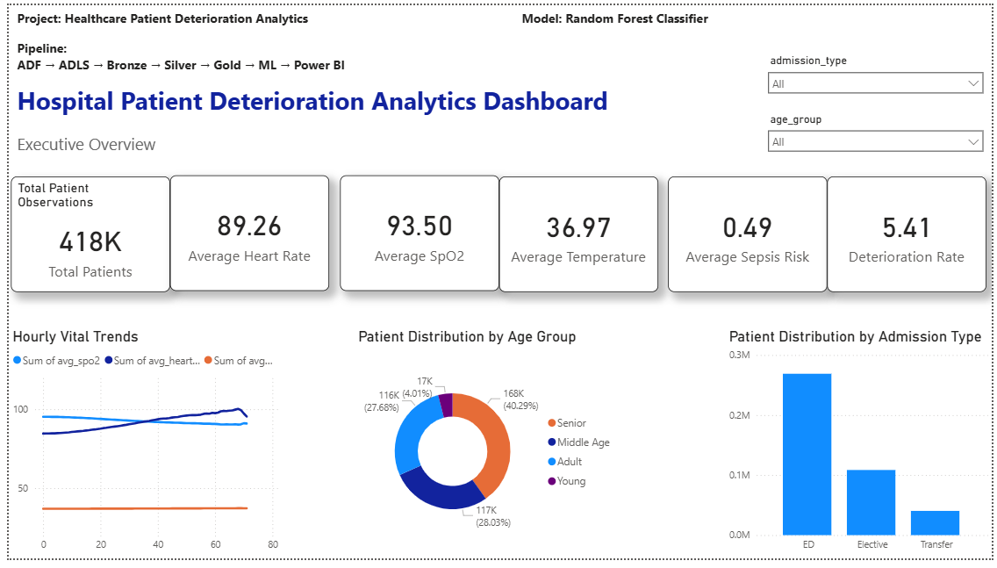

Results and Key Findings
The project successfully demonstrates the implementation of a scalable healthcare analytics platform using Microsoft Azure and Apache Spark.
Key Outcomes
- Successfully processed more than 4,17,000 patient observations.
- Automated ingestion of 50 healthcare CSV files using Azure Data Factory.
- Implemented the Medallion Architecture using Delta Lake.
- Applied comprehensive data validation and feature engineering in the Silver layer.
- Generated business-ready analytical datasets in the Gold layer.
- Developed an end-to-end Spark ML pipeline for patient deterioration prediction.
- Built an interactive three-page Power BI dashboard for healthcare analytics.

Project Folder Structure

Healthcare-Patient-Deterioration-Analytics/
│
|── adf/
│ └── Healthcare_Data_Ingestion_Pipeline.json
│
|── databricks/
│ |── bronze/
│ |── silver/
│ |── gold/
│ |── ml/
│ └── export/
│
|── powerbi/
│ └── Healthcare_Analytics.pbix
│
|── architecture/
│ |── solution_architecture.png
│ |── medallion_architecture.png
│ └── end_to_end_data_flow.png
│
|── screenshots/
│ |── adf_pipeline.png
│ |── bronze_layer.png
│ |── silver_layer.png
│ |── gold_layer.png
│ |── dashboard_page1.png
│ |── dashboard_page2.png
│ └── dashboard_page3.png
│
|── docs/
│
└── README.md

How to Run the Project
Prerequisites
- Azure Subscription
- Azure Data Factory
- Azure Data Lake Storage Gen2
- Azure Databricks
- Power BI Desktop
- Python 3.14
- Apache Spark
Steps
- Upload healthcare CSV files to the source storage container.
- Execute the Azure Data Factory pipeline to ingest raw files into ADLS Gen2.
- Run the Bronze notebook to create raw Delta tables.
- Run the Silver notebook to perform validation and feature engineering.
- Run the Gold notebook to generate analytical datasets.
- Execute the Machine Learning notebook to train and evaluate the Random Forest model.
- Export Gold datasets to CSV.
- Open the Power BI report and refresh the data to visualize the latest results.

Conclusion
This project demonstrates the design and implementation of an end-to-end healthcare analytics platform using Microsoft Azure and Apache Spark. By adopting the Medallion Architecture, the solution transforms raw healthcare records into trusted analytical datasets through structured data ingestion, validation, transformation, and aggregation processes.
The integration of a Spark ML-based Random Forest classifier extends the platform beyond descriptive analytics by enabling predictive modeling for patient deterioration. Finally, interactive Power BI dashboards provide stakeholders with actionable insights into patient health trends, clinical risk factors, and high-risk patient monitoring.
The project showcases modern cloud data engineering practices, scalable big data processing, and business intelligence techniques within a unified architecture.

